**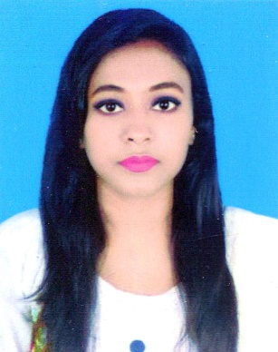 *Resume Of***

**Nasrin Akter Sahenour**

**Address:** Kha-34, Shajadpur, Gulshan Model Town, Dhaka 1212

**Cell : +88**01689-737656

**Email :** 11nasrin.akter11@gmail.com

# Career Objective :

To work with sincerity and integrity in a challenging atmosphere where my talent and knowledge

will significantly contribute to the organization’s target achievement and to become a successful person with excellent career where hard work, strict discipline and creative problem solving are the corner stone of success.

**Educational Qualification:**

**Bachelor of Business Administration:**

Name of institution : Presidency University Department : BBA

Major : Finance

CGPA : 2.90 out of 4.00

Passing year : 2016

## Higher Secondary Certificate (H.S.C) :

Name of institution : T & T Mohila College.

Board : Dhaka

Group : Business Studies

GPA : 3.30 out of 5.00

Passing year : 2010

## Secondary School Certificate (S.S.C) :

Name of institution : Khilbarirtek Islamia High School.

Board : Dhaka

Group : Business Studies

GPA : 3.13 out of 5.00

Passing year : 2008

**Experience on Software Tools and Others :**

* Working capability on windows 98, XP, 7, 8, 10 and Other Operating System
* Office Applications- MS Word, MS Excel, MS Power Point
* Clear Concept on Internet, Browsing, mailing.

# Language Proficiency :

|  |  |  |  |
| --- | --- | --- | --- |
| Language | Reading | Writing | Speaking |
| Bangla | High | High | High |
| English | High | High | Medium |

## Experience In Work :

❖ Institute Name : Service Chai

Institute Type : BPO/Call Center

Designation : CSE

Job Duration : 7 Months running

|  |  |
| --- | --- |
| * Institute Name | : Genex Infosys Ltd. (Uber Process) |
| Institute Type | : BPO/Call Center |
| Designation | : Customer Support Associate |
| Job Duration | : 14th April 2018 to 25th May 2020 |

|  |  |
| --- | --- |
| * Institute Name | : Digicon Technologies Limited (Grameenphone Process) |
| Institute Type | : BPO/Call Center |
| Designation | : Customer Service Representative |
| Job Duration | : 1Year |

|  |  |
| --- | --- |
| * Institute Name | : FIFO Tech |
| Institute Type | : Outsourcing call center |
| Designation | : BPO Operator |
| Job Duration | : 1 Year |

# Self-specialties :

* Leadership skills in small groups.
* Hard-working & diligent abilities,
* Good command on English.
* Quick learn ability for adopting new technologies.

# Personal Details :

Father’s Name : Late Samir Uddin

Occupation : Business

Mother’s Name : Masuda Begum

Occupation : Housewife

Date of Birth : 26th February,1991

Gender : Female

Blood Group : A+

Nationality : Bangladeshi by Birth

Religion : Islam

Marital Status : Unmarried

Present Address : House: KHA- 34, Post: Gulshan, Dhaka - 1212

Permanent Address : House: KHA- 34, Post: Gulshan, Dhaka - 1212

**Your Faithfully,**



## Nasrin Akter Sahenour